**WEEK-6:**

**Aim** : Prepare a resume application to collect the details of the Student

**Procedure:**

Tags Used**:**<label>,</label>,<input>,<form>,</form>

<!DOCTYPE html>

<html lang="en">

<head>

<title>HTML forms</title>

</head>

<body>

<center>

<h1>RIZWAN FORMS</h1>

</center>

<label for="firstname">First name &ensp;&nbsp;&emsp;&ensp;: &nbsp;</label>

<input type="text" id="fname" name="firstname" placeholder="John" required/><br /><br>

<label for="lastname">Last name &ensp;&nbsp;&emsp;&ensp;: &nbsp;</label>

<input type="text" id="lname" name="lastname" placeholder="Doe" required/><br /><br />

<label for="gender">Gender &ensp;&nbsp;&emsp;&emsp;&ensp;&ensp;: &nbsp;</label>

<input type="radio" id="male" name="gender" required/>

<label for="male">Male</label>

<input type="radio" id="female" name="gender" />

<label for="female">Female</label><br /><br>

<textarea name="address" rows="4" cols="30"></textarea>

<label for="dept">Department &ensp;&emsp;:&nbsp;&nbsp;</label>

<select id="branch" name="branch">

<option value="option">--- Select an option ---</option>

<option value="cse">CSE</option>

<option value="it">IT</option>

<option value="ece">ECE</option>

<option value="eie">EIE</option>

<option value="civil">CIVIL</option>

<label for="singing">Web Development</label>&ensp;<br>&emsp;&emsp;&emsp;&emsp;&emsp;&emsp;&emsp;&nbsp;&nbsp;

<input type="checkbox" id="dancing" name="dancing" value="dancing">

<input type="checkbox" id="photography" name="photography" value="photography">

<label for="photography">C</label>&ensp;<br>&emsp;&emsp;&emsp;&emsp;&emsp;&

</form>

</body>

</html>

**OUTPUT:**

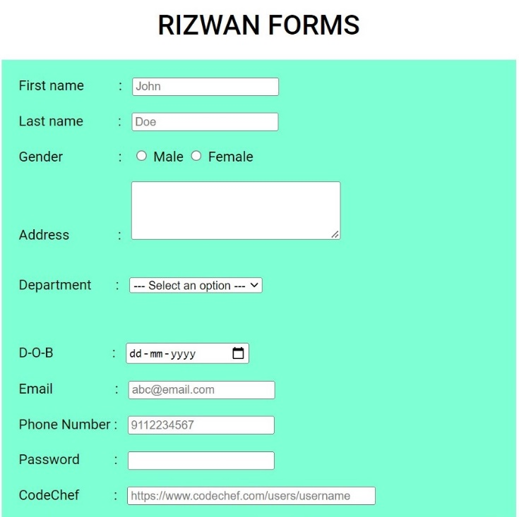

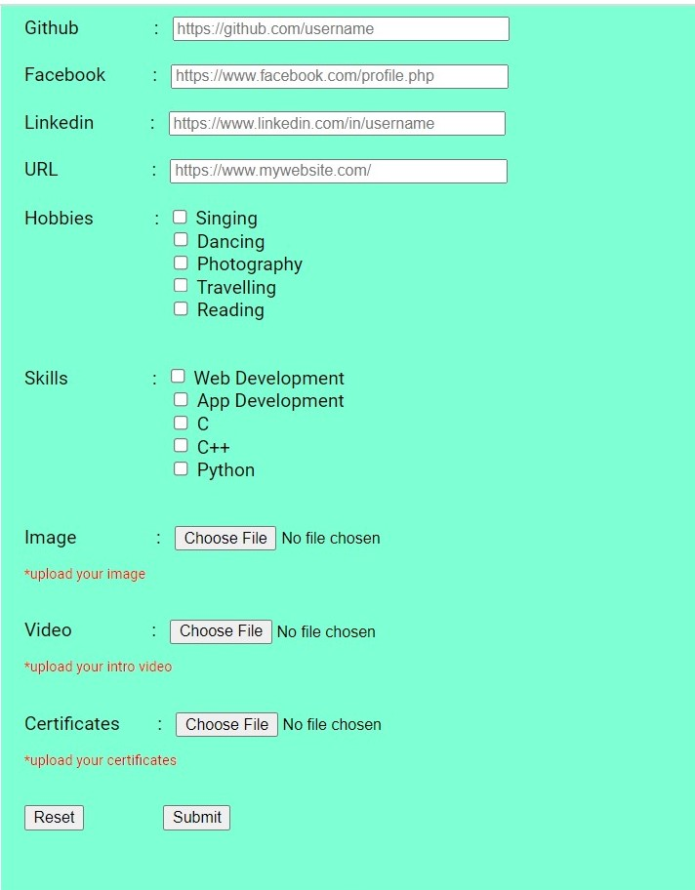

**WEEK 8**

**Aim**: create a website using HTML

**Code:**

<!DOCTYPE html>

<html lang="en">

<head>

<title>Foodie Plaza</title>

</head>

<body>

<!-- Navigaion Bar -->

<header>

<!-- <p class="logo">Foodie Plaza</p> -->

<img class="main-logo" src="images/logo.png" alt="logo">

<nav>

<ul class="nav-links">

<li><a href="index.html">Home</a></li>

<li><a href="#bring-about">About</a></li>

<li><a href="desserts.html" target="_blank">Desserts</a></li>

</ul>

</nav>

<button><a href="login.html" target="_blank">Login/SignUp</a></button>

</header>

<!-- Top Section -->

<div class="wrap-banner">

<div class="wrap">

<h1 class="tag">

The Fastest Delivery in <span class="theme-color">Your City</span>

</h1>

<h1 class="typing">Order Now : <span class="animate"></span></h1>

</div>

<img src="images/about.png" alt="food-illustration" />

</div>

<!-- Menu Section -->

<h3 class="sub-heading">Our Dishes</h3>

<h1 class="heading">popular dishes</h1>

<div id="bring-menu" class="grid-wrapper">

<div class="menu-item">

<img src="images/dish-1.png" alt="" />

<p class="item-name">Burger</p>

<div class="stars">

<i class="fas fa-star"></i>

<i class="fas fa-star"></i>

<i class="fas fa-star"></i>

<i class="fas fa-star"></i>

<i class="fas fa-star-half-alt"></i>

</div>

<p class="item-cost">₹ 249/-</p>

<button class="cart">

<a href="login.html" target="_blank">Add to cart</a>

</button>

<button class="cart">

<a href="login.html" target="_blank">Order now</a>

</button>

</div>

<div class="menu-item">

<img class="put-down" src="images/dish-2.png" alt="" />

<p class="item-name">Chicken Nugget</p>

<div class="stars">

<i class="fas fa-star"></i>

<i class="fas fa-star"></i>

<i class="fas fa-star"></i>

<i class="fas fa-star-half-alt"></i>

</div>

<p class="item-cost">₹ 199/-</p>

<button class="cart">

<a href="login.html" target="_blank">Add to cart</a>

</button>

<button class="cart">

<a href="login.html" target="_blank">Order now</a>

</button>

</div>

<div class="menu-item">

<img src="images/dish-3.png" alt="" />

<p class="item-name">Barbecue chicken</p>

<div class="stars">

<i class="fas fa-star"></i>

<i class="fas fa-star"></i>

<i class="fas fa-star"></i>

<i class="fas fa-star"></i>

<i class="fas fa-star-half-alt"></i>

</div>

<p class="item-cost">₹ 475/-</p>

<button class="cart">

<a href="login.html" target="_blank">Add to cart</a>

</button>

<button class="cart">

<a href="login.html" target="_blank">Order now</a>

</button>

<!-- Hungry Section -->

<div class="grid-banner">

<div>

<h3 class="sub-heading">Hungry!!!!</h3>

<h1 class="heading">Order Now..</h1>

</div>

<div>

<img src="images/loader.gif" alt="" class="center" />

</div>

</div>

</body>

</html>

**Login.html:**

<!DOCTYPE html>

<html lang="en">

<head>

<title>Login</title>

</head>

<body>

<div class="login-box">

<h2>Login</h2>

<form action="" class="form">

<div class="user-box">

<input class="input" type="text" id="" required="">

<label class="label" for="">Username</label>

</div>

<!-- /.user-box -->

<div class="user-box">

<input class="input" type="password" id="" required="">

<label class="label" for="">Password</label>

</div>

<!-- /.user-box -->

<a href="#">

<span></span>

<span></span>

<span></span>

<span></span>

Login

</a>

</form>

<!-- /form -->

<p class="sign-up">Don't have an account <a href="signup.html">Sign Up</a> here</p>

</div>

<!-- /.login-box -->

</body></html>

**OUTPUT:**

